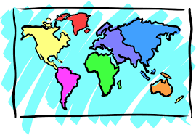
Curriculum Knowledge Organiser
Geography
Vocabulary
Capital City | A city or town which is the governments central meeting place.
Human Features | The human environment of an area such as population, buildings, land use or transport.
Landmarks | A features of a city that can be easily seen and recognised.
London | The capital city of the United Kingdom.
Maps | A drawing on an area showing physical features such as roads and rivers.
Physical Features | The natural features of an area, such as rivers, hills, mountains or oceans.
Town | A built up area, larger than a village, smaller than a city.
Transport | The vehicles that people use to move around an area.
United Kingdom | A kingdom in Europe made up of the four countries of England, Scotland, Wales and Northern Ireland.
Key Questions
What do these symbols mean on a map? Can you name 3 human features in our local area? Can you name 3 physical features in our local area? Describe your route to school? Using this map describe the position of the teddy bear to a friend.
YEAR 1 - AUTUMN TERM
GEOGRAPHY: Human and Physical features of London.
Name the four countries of the UK, know that London is the capital city of the UK, begin to know the differences between town and country locations, use a map to locate places and landmarks, use photographs to recognise basic human and physical features of London, describe human and physical features of the capital city London, use internet mapping programmes to observe aerial views and explain the differences between London and their own local city.

United Kingdom Cities and Counties
